**MACHINE PROBLEM NO. 3**

Screenshots and Proof of Testing

**CODE:**

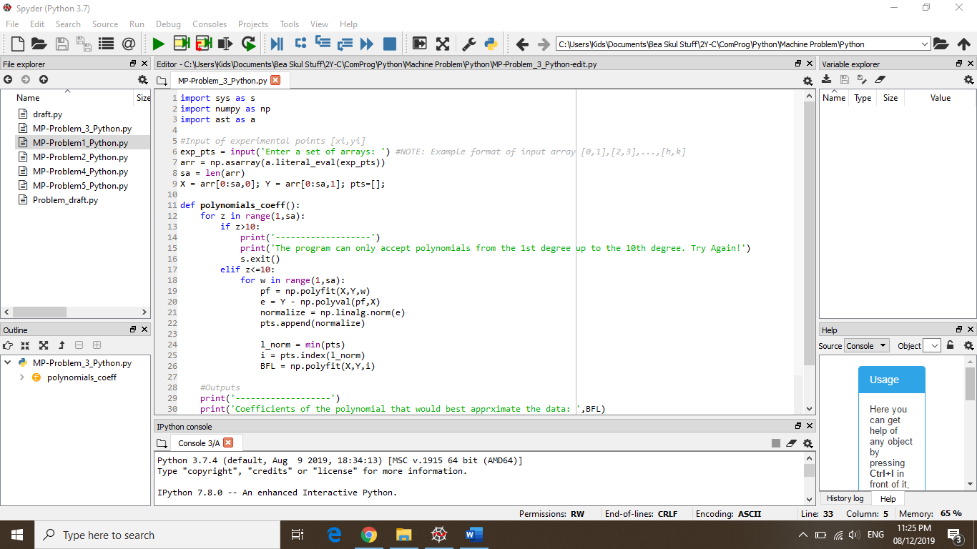

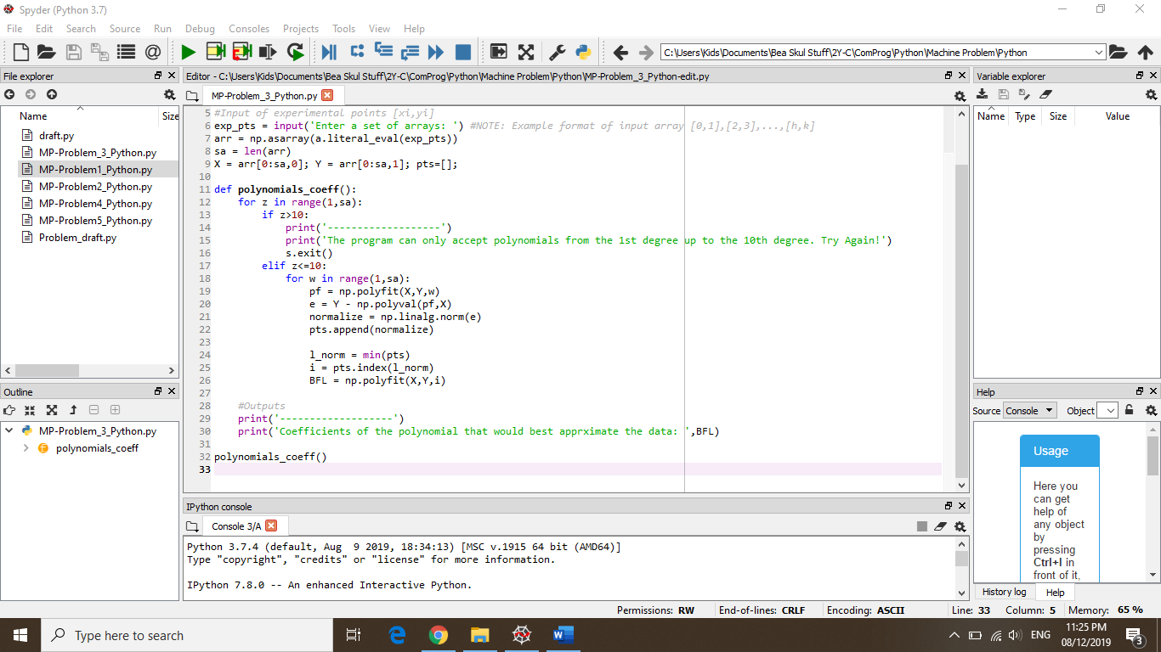

**TRIAL #1:**

* Input: [1,2], [3,4], [5,6]

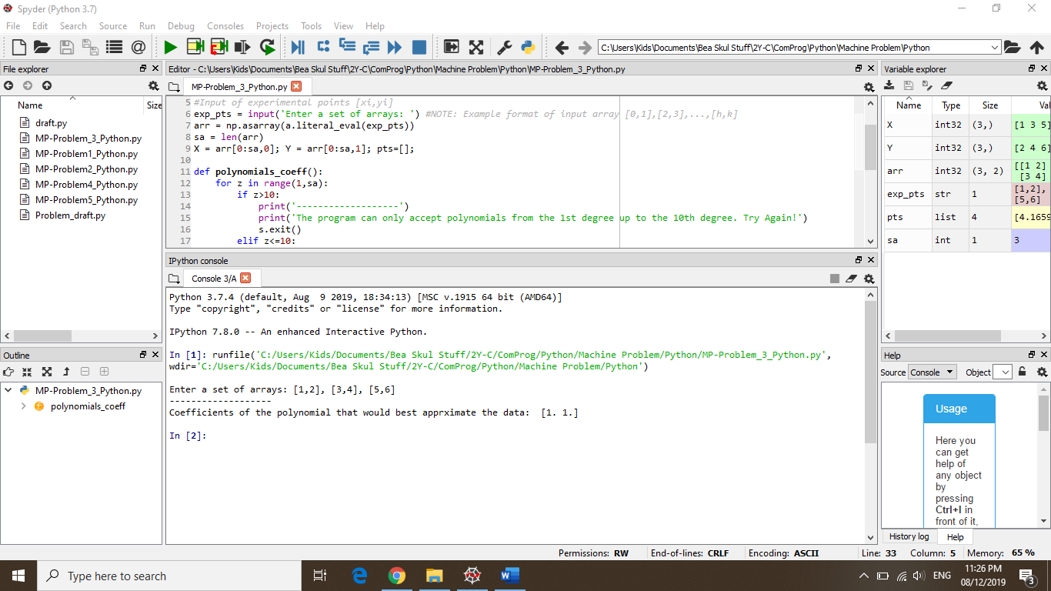

**TRIAL #2:**

* Input: [10,11], [14,16], [20,22], [2,4], [9,3]

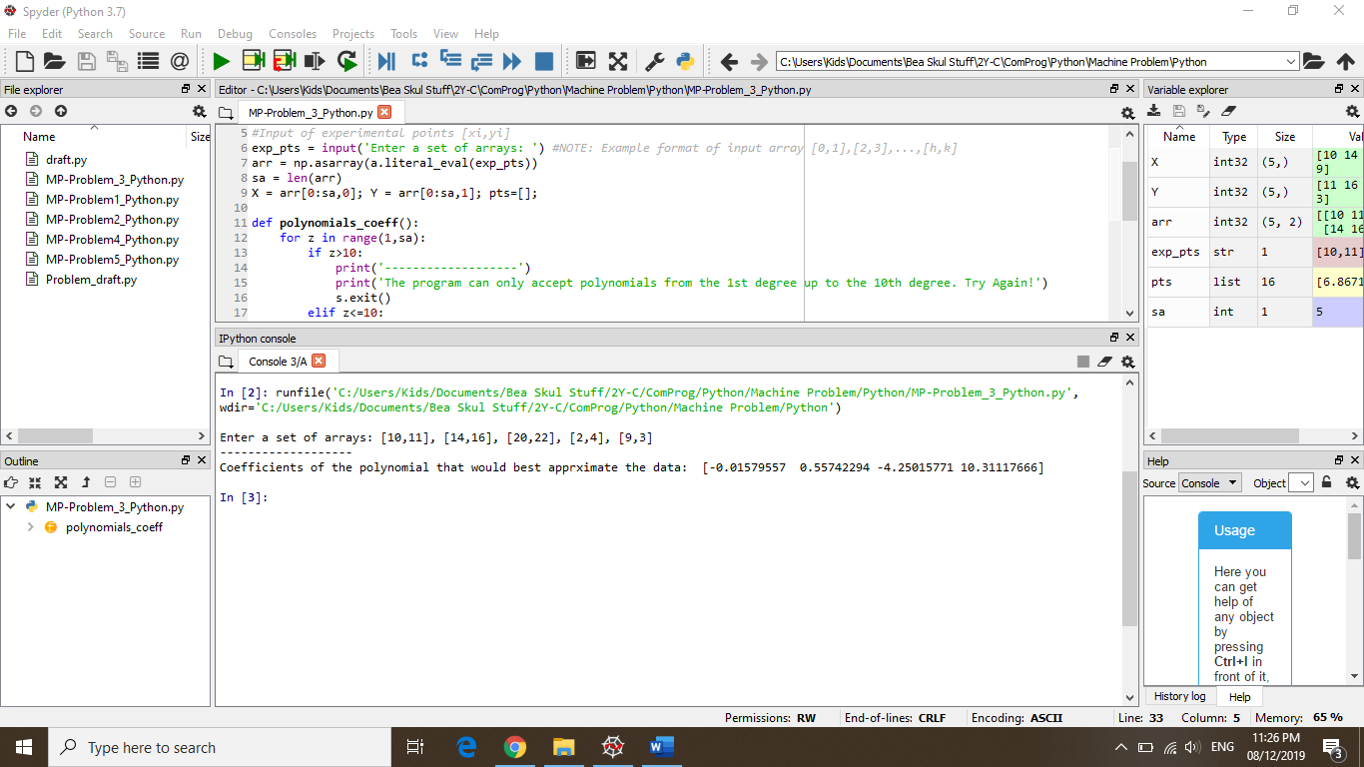

**TRIAL #3 (error):**

* Input: [1,2], [3,4], [5,6], [7,8], [9,10], [11,12], [13,14], [15,16], [17,18], [19,20], [21,22], [23,24], [25,26]

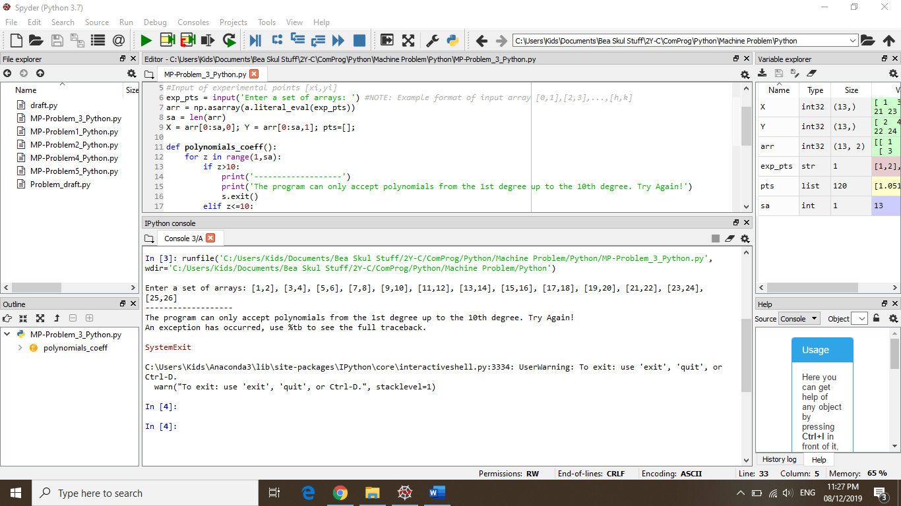

**TRIAL#4 (error):**

* Input: [1,1], [2,2], [3,3], [4,4], [5,5], [6,6], [7,7], [8,8], [9,9], [10,10], [11,11], [12,12], [13,13], [14,14], [15,15]

